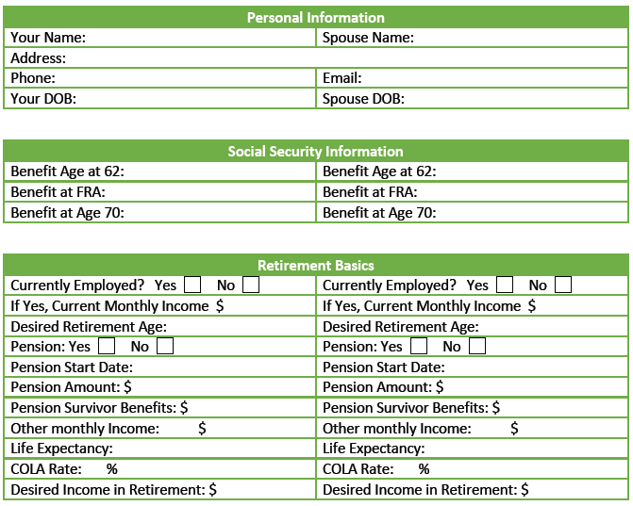

**How did you hear about us?** __________________________________________________

**Kids ages?** _______________________________________________________________

**Company Match?** _____% _____%

**How much are you putting towards match?** _____% _____%

**What percentage of your assets would you like NO risk and have some participation in the market?** _______%

**Total Monthly Expenses approximately:** **$** _________

**Additional Notes:** _____________________________________________________________

____________________________________________________________________________

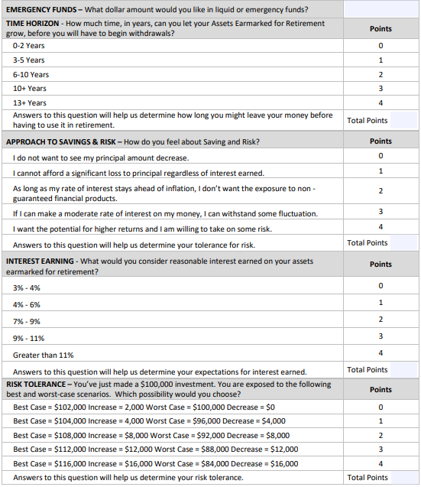

**Additional Notes:**

**Do you currently have a financial advisor? Yes/No**

**If Yes, what firm?** ______________________________________­­­­­­________________

**How long have you been with your current financial advisor?** ________________________

**On a scale of 1 to 10 (10 being the best), how would you rate your current advisors?** ______

